**WEEK – 2 ASSIGNMENT: DAX and Dashboard (Visualization)**

* **OBJECTIVES:**
* Understanding Data Analysis Expressions for the Project Context
* Prepare New Measures and New Columns using DAX Functions according to the Project requirements
* Understanding the Various Charts and their usage
* Visualize the text data into Charts
* Apply filter(s) on the Chart, if needed.
* To show the partial output with the help of Power BI Visualization, saving, sharing the projects, etc.
* **New Measures Creation – Steps Done:**
* First, we are creating a new measure called “**Total Cost**” (which contains the total cost including all type of energy consumed) under the table Energy Consumptions.

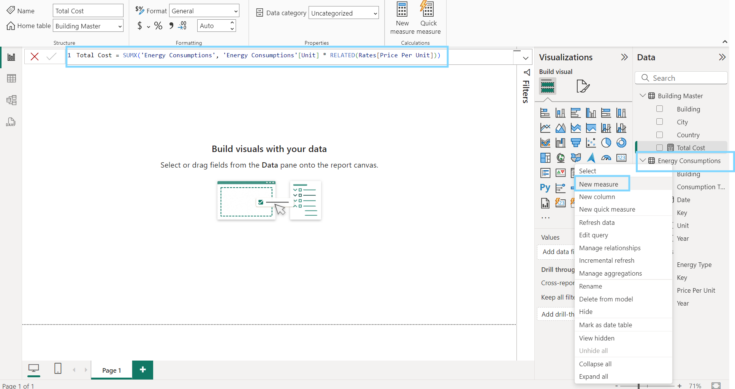

**Formula Expression:** Total Cost = SUMX('Energy Consumptions', 'Energy Consumptions'[Unit] * RELATED(Rates[Price Per Unit]))

* Secondly, we create another measure called “**Unit Consumed**” (which contains the total unit consumption) under the table Energy Consumptions.

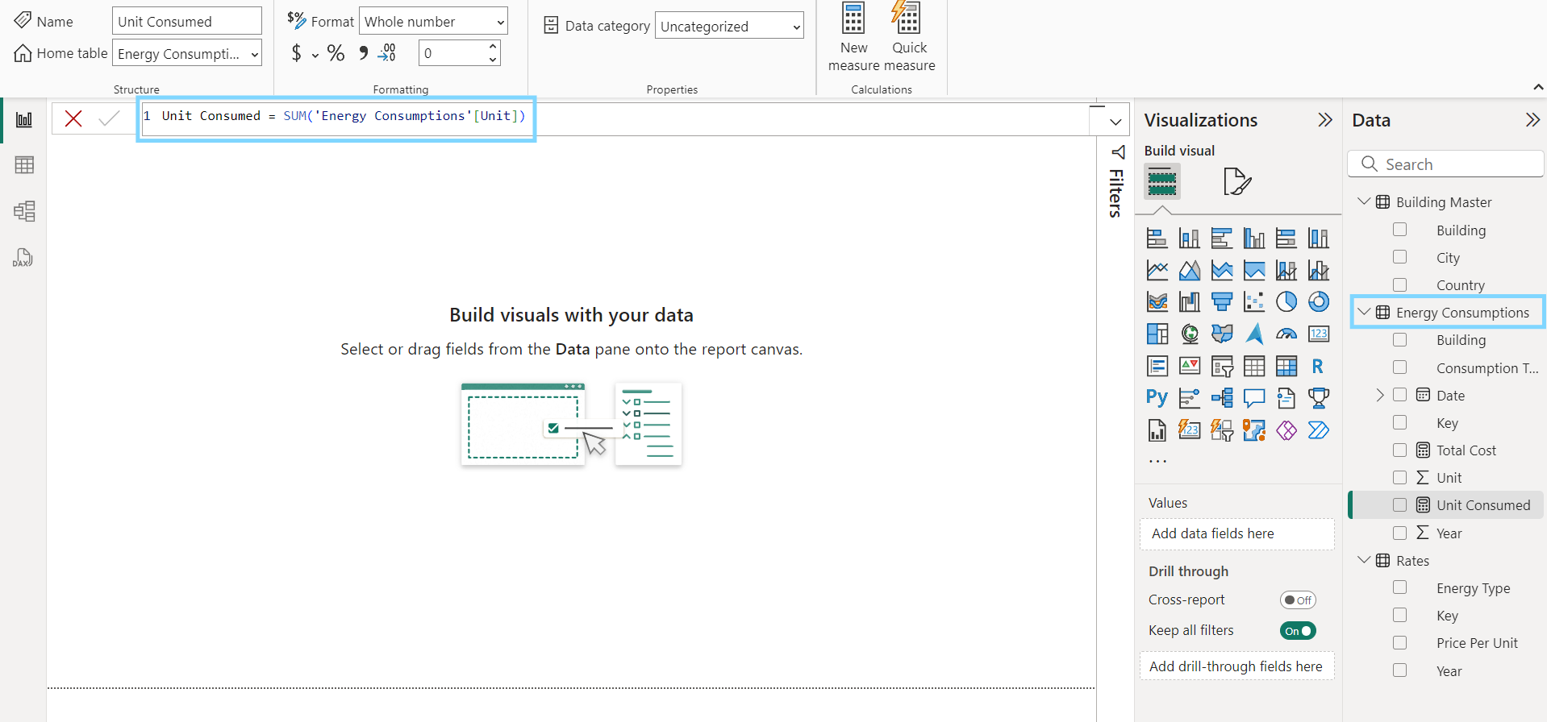

**Formula Expression:** Unit Consumed = SUM('Energy Consumptions'[Unit])

* **Data Visualization – Steps Done:**
* Firstly, lets start with adding some background colour to the canvas under Visualizations Tab 🡪 Canvas background.

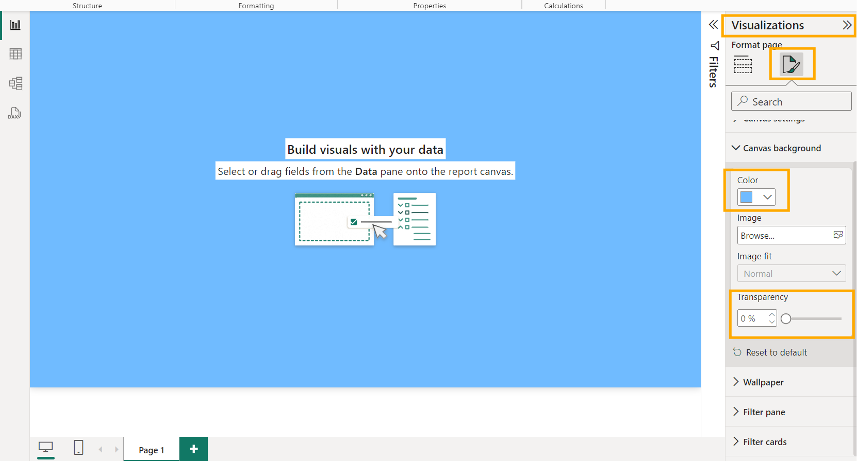

* Inserted a line at top of canvas and added an image and header texts for our dashboard.
* Now start adding “**Cards**”. Here we added **Total cost** and **Unit consumed** values (using measures we’ve created) to show visually.

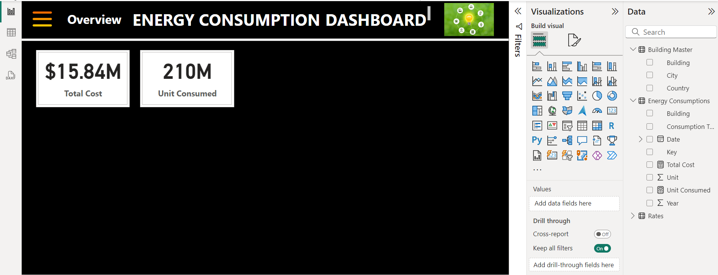

* Next adding the “**Slicers**” such as **Consumption Type, Building, City, Date Interval** to enable filtering options for our dashboard.

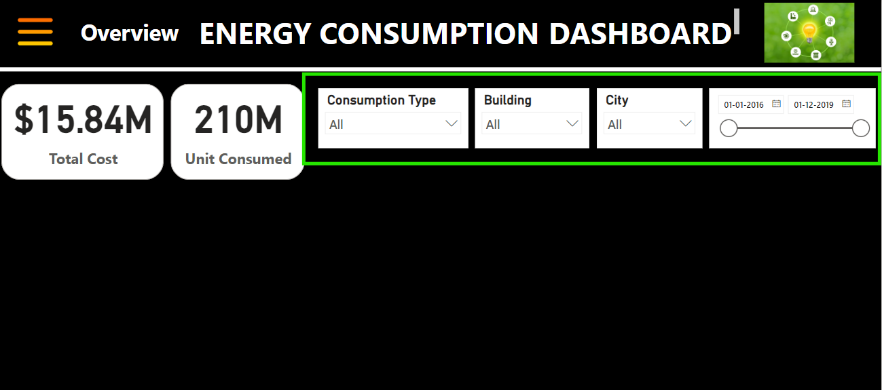

* Adding “**Map**” visual with bubbled representation to show total energy cost for each city.

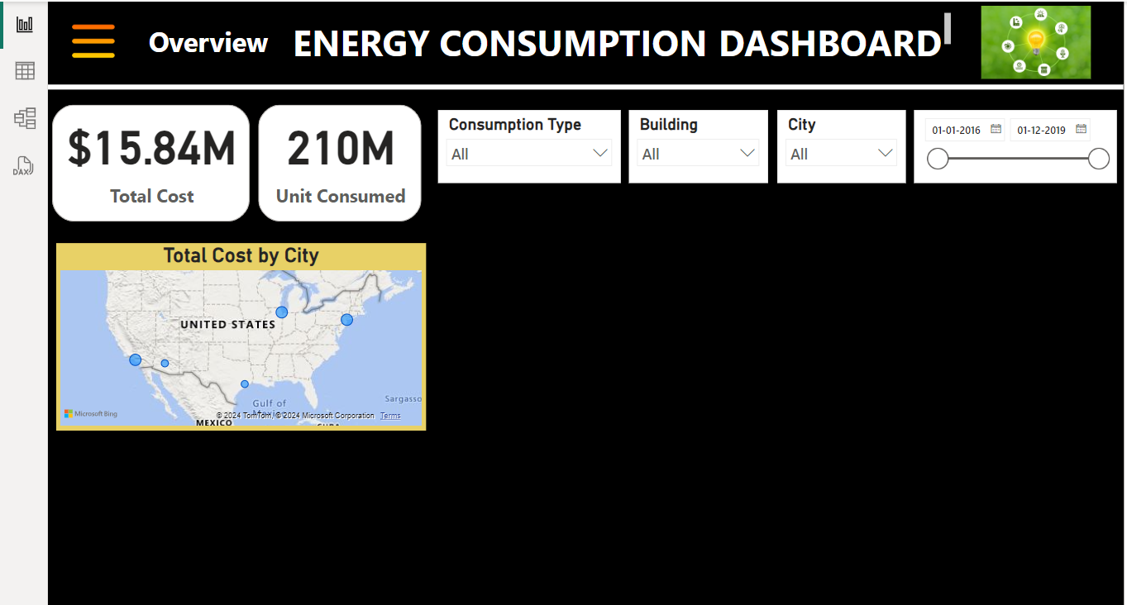

* Next adding “**Stacked Chart”** type to show visual representation of comparison between how much Total cost and Consumption type are changing over time.

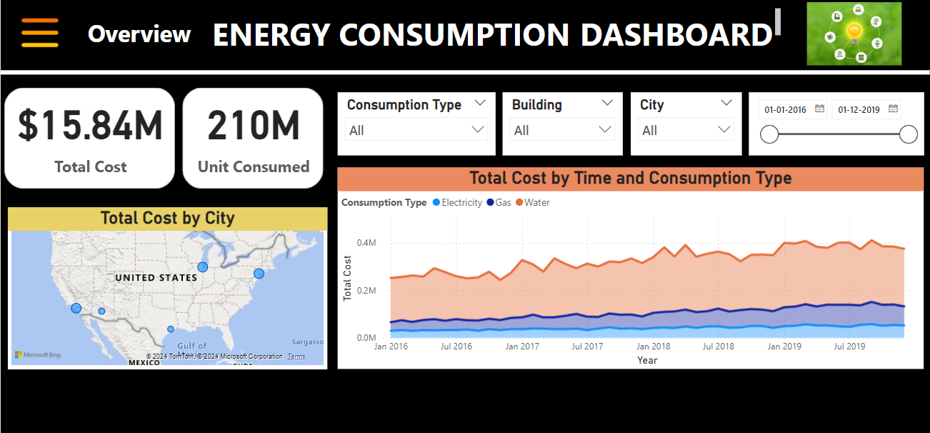

* Then, adding a dynamic “**Narrative**” visual to show the quick summary and trends about the selected city.

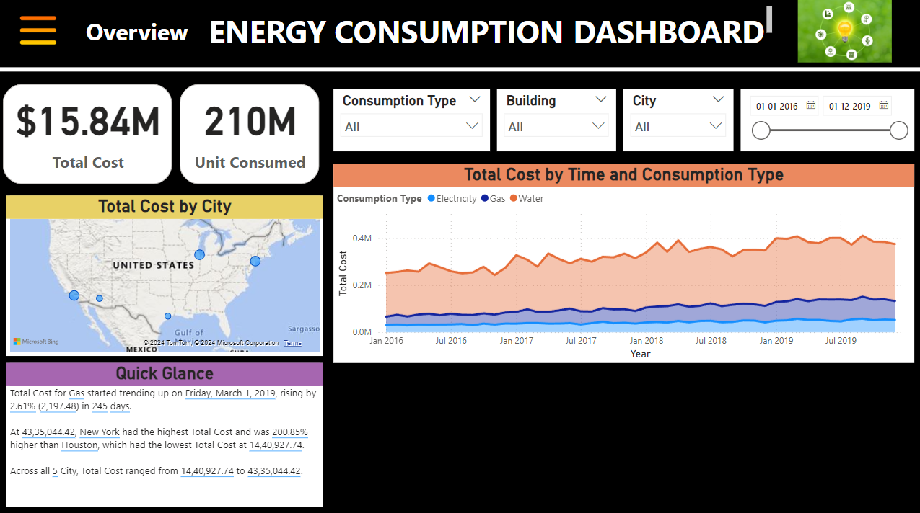

* Now adding **“Donut chart”** to show the visual representation of total unit consumption by each energy category.

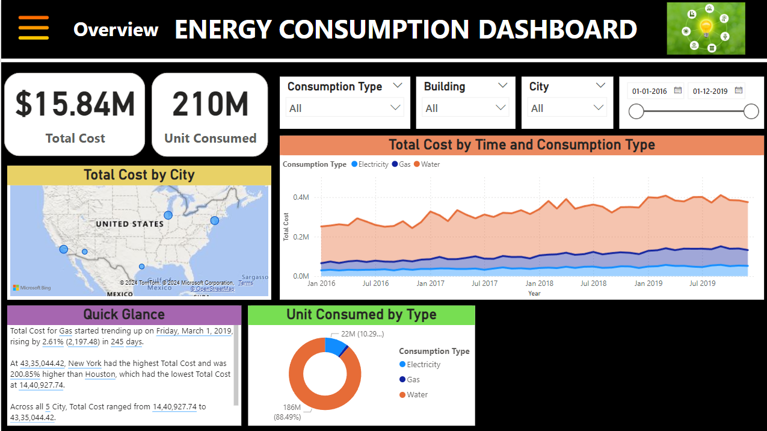

* Lastly, adding “**Column Chart**” to visually represent total no of units consumed by each building from 2016 – 2019.
* Here’s below the final overview dashboard,

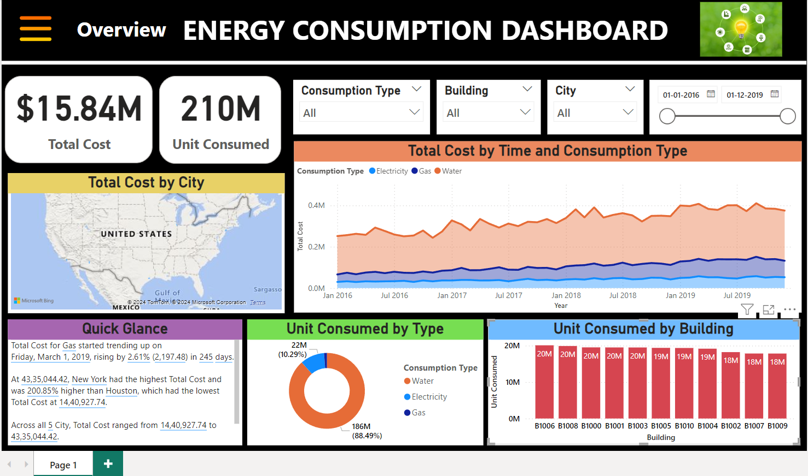

* **CONCLUSION:**

Below tasks are completed as part of Week-2 milestone.

* Created new measures and columns using DAX.
* Gained an understanding of various chart types and their usage scenarios.
* Selected appropriate charts and visualized text data effectively.
* Applied filters to charts as needed for enhanced data representation and insights.
* Successfully created partial overview dashboard for energy analysis in Power BI.